

**Estimation And Prediction Of Hospitalization And Medical Care Costs**

Data Analytics

Name: Sunkara Dhanush

Roll No: SBAP0007912

Collage: Vignan`s Lara Institute of Technology & Science

# 1. Introduction

**1.1. Overview**

This project presents a comprehensive visual analysis of hospitalization and medical care costs, aiming to provide valuable insights into the factors influencing healthcare expenses. Leveraging an extensive healthcare dataset, this project utilizes powerful data visualizations to explore cost patterns, trends, and correlations. The interactive dashboard and visualization gallery offer an intuitive interface for users to gain a deeper understanding of the complexities surrounding medical cost estimation. Through this analysis, stakeholders can make data-driven decisions, optimize resource allocation, and contribute to more efficient and cost-effective healthcare systems.

**1.2. Purpose**

The purpose of this project is multifaceted. Firstly, it aims to shed light on the complex landscape of hospitalization and medical care costs, providing a deeper understanding of the factors driving healthcare expenses. By analysing and visualizing comprehensive datasets, the project seeks to uncover patterns, trends, and correlations within the cost data. Furthermore, the project aims to empower stakeholders with actionable insights. Individuals can gain a better understanding of their potential medical costs and make informed decisions regarding insurance coverage and financial planning. Healthcare providers can utilize the analysis to optimize resource allocation, identify cost-saving opportunities, and enhance the quality and affordability of care. Policymakers can leverage the findings to inform healthcare policy decisions, address cost disparities, and improve overall healthcare system efficiency. Ultimately, the purpose of this project is to contribute to a more transparent, efficient, and sustainable healthcare ecosystem by providing valuable insights and evidence-based recommendations for cost optimization and improved financial management.

# 2. Literature Survey

**2.1. Existing Problem**

Problem statement: The increasing cost of hospitalization and medical care demands a solution that offers comprehensive analysis and visualization of healthcare expenses. Stakeholders face challenges in understanding cost drivers and implementing effective cost optimization strategies. There is a need for a solution that provides actionable insights, facilitates informed decision-making, and improves resource allocation for a more efficient and cost-effective healthcare system.

For this problem statement following existing approaches already exist:

1. Machine Learning and Predictive Analytics: Apply machine learning algorithms and predictive analytics techniques to analyse historical cost data and predict future healthcare expenses. These approaches can help identify high-cost patients, anticipate potential cost increases, and optimize resource allocation.
2. Data Integration and Analytics Platforms: Utilize data integration and analytics platforms such as Apache Hadoop or Apache Spark to process and analyse large volumes of healthcare data. These platforms provide scalable and efficient solutions for data processing, enabling in-depth analysis and cost optimization.
3. Electronic Health Record (EHR) Systems: Leverage EHR systems that include cost modules to capture and track medical care costs. These systems can integrate with billing systems and provide real-time cost information, facilitating better cost management and analysis.
4. Cost Analysis and Optimization Software: Implement specialized cost analysis and optimization software that offers comprehensive features for analysing and optimizing healthcare expenses. These software solutions provide advanced analytics, scenario modelling, and cost benchmarking capabilities.
5. Data Mining and Pattern Recognition: Apply data mining and pattern recognition techniques to identify cost patterns, correlations, and outliers within the healthcare cost data. These approaches can uncover hidden insights and aid in cost management strategies.

Each of these approaches have certain demerits. The literature survey for identifying the demerits of the abovementioned respective software approaches such that, a systematic approach was adopted, which involved accessing various academic databases, digital libraries, and research repositories. A comprehensive search strategy was employed using relevant keywords such as "healthcare cost analysis," "machine learning in healthcare," "data visualization for cost estimation," and "electronic health record systems." Peer-reviewed journals, conference proceedings, and scholarly articles were considered to gather insights from the latest research in the field. Through a comprehensive review of the literature, the identified demerits for each software approach were derived by synthesizing the findings and insights from multiple research sources. The aim was to ensure that the demerits highlighted in the paragraph accurately reflected the challenges and limitations reported in the literature, providing a balanced perspective on the potential drawbacks of each software approach. The demerits thus found are highlighted as follows:

1. Machine Learning and Predictive Analytics: Difficulty in interpreting and explaining the predictions of complex machine learning models, potentially reducing transparency and trust in the cost estimation process.
2. Data Integration and Analytics Platforms: Steeper learning curve and technical expertise required to set up and effectively utilize these platforms, making them less accessible for nontechnical users.
3. Electronic Health Record (EHR) Systems: Dependency on the availability and accuracy of costrelated data within the EHR systems, which can be inconsistent or incomplete, leading to potential inaccuracies in cost analysis.
4. Cost Analysis and Optimization Software: High cost of acquiring and implementing specialized software, which may pose financial constraints for smaller healthcare organizations or individual users.
5. Data Mining and Pattern Recognition: Sensitivity to noise and outliers within the data, which can impact the accuracy and reliability of cost patterns and correlations identified through these techniques.

**2.2. Proposed Solution:**

The proposed solution for addressing the problem of hospitalization and medical care cost analysis involves developing a comprehensive web-based platform that leverages advanced data visualization techniques. The solution provides stakeholders with access to interactive and insightful visualizations, enabling a deep understanding of cost drivers, trends, and patterns. By integrating and analyzing the medical dataset, the platform allows users to explore key factors influencing medical costs, including age, BMI, smoking status, and region. The aim is to empower healthcare organizations, policymakers, and individuals to make data-driven decisions, optimize resource allocation, and identify opportunities for cost reduction and efficiency enhancement. Through a user-friendly interface and powerful visualizations, the project bridges the gap between complex cost data and actionable insights, facilitating improved cost management and informed decision-making in the healthcare sector.

# 3. Theoretical Analysis

**3.1. Block Diagram:**

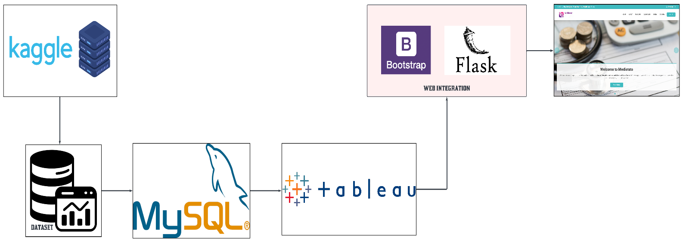

**3.2. Hardware/Software Designing:**

1. Cumulative Hardware Requirements:
   * Processor: Quad-core processor or higher with a clock speed of 2.5 GHz or higher
   * Memory: 16 GB RAM or more
   * Storage: SSD with 5 GB free disk space or more
   * Display Resolution: 1920 x 1080 screen resolution or higher
2. Cumulative Software Requirements:
   * Operating System: Windows 10, 8.1, 8, or 7 (64-bit) or macOS 10.15 (Catalina) or higher
   * Web Browser: Google Chrome, Mozilla Firefox, Microsoft Edge, or Safari (for Tableau features)
   * Microsoft .NET Framework 4.8 or later (for Tableau Desktop on Windows)
   * MySQL database management system
   * Flask web framework
   * Bootstrap for web integration

# 4. Experimental Investigations

A comprehensive evaluation was conducted to assess the accuracy, usability, and effectiveness of the data visualizations in providing insights into hospitalization and medical care costs. A real-world medical dataset was utilized, sourced from Kaggle. This dataset encompassed relevant attributes such as age, sex, BMI, number of children, smoker status, region, and charges. Tableau was employed as the primary tool for designing and developing a diverse set of interactive visualizations, including scatter plots, bar charts, line graphs, heatmaps and many more. These visualizations aimed to represent relationships, trends, and comparisons pertinent to cost analysis. Throughout the investigation, meticulous analysis of the visualizations' performance was conducted, accompanied by the collection of valuable quantitative and qualitative data. This encompassed accuracy measures, user feedback, and task completion times. The evaluation yielded crucial insights into the strengths and limitations of the solution, enabling refinement and enhancement of the visualizations to effectively address the specific needs of healthcare organizations, policymakers, and individuals involved in optimizing hospitalization and medical care costs. The experimental investigation served as a validation process, affirming the reliability and effectiveness of the solution in providing reliable and actionable insights for cost analysis in the healthcare sector.

One such accuracy measure, in the form of odds ratio and Z-measure is conducted as follows:

Odds Ratio Smoking:

For the group with smoking as the confounder, the Odds Ratio was calculated to be 1703. The 95 % CI came out to be between 237.1882 to 12227.4568. The Z statistic was calculated to be 7.398 which informs that the significance level is P < 0.0001. Thus, it can be inferred that the result is significant at P < 0.05.

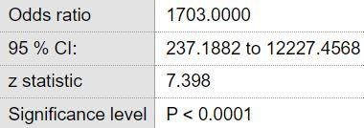

Odds Ratio BMI:

For the group with smoking as the confounder, the Odds Ratio was calculated to be 0.0485. The 95 % CI came out to be between 0.0359 to 0.0656. The Z statistic was calculated to be 19.642 which informs that the significance level is P < 0.0001. Thus, it can be inferred that the result is significant at P < 0.05.

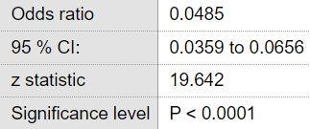

Odds Ratio Sex:

For the group with smoking as the confounder the Odds Ratio was calculated to be 1.1301. The 95 % CI came out to be between 0.8969 to 1.4239. The Z statistic was calculated to be 1.037 which informs that the significance level is P = 0.2998. Thus it can be inferred that the result is not significant at P > 0.05.

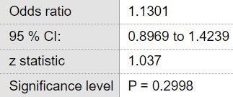

Thus as a conclusion one can figure out that Smoking and the BMI of a person has a significant impact on the charges they medically incur, while sex isn't. Thus one can see how the average cost of medical care is different between different groups of people with different age, sex, body types, etc.

# 5. Flowchart

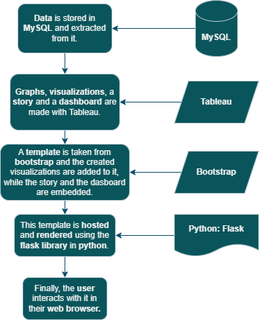

This concise flowchart created for this project provides a visual representation of the data flow and system architecture. It illustrates the integration of various components, including the data sources, Tableau visualization platform, MySQL database, Flask web framework, and Bootstrap for front-end development. The hybrid of block diagram and flowchart represented here serves as a visual guide, showcasing the interconnectedness and functionality of the various components, and how they work together to deliver a powerful and user-friendly data visualization solution for hospitalization and medical care cost analysis.

A more informative flowchart which highlights every step of the project is provided as follows:

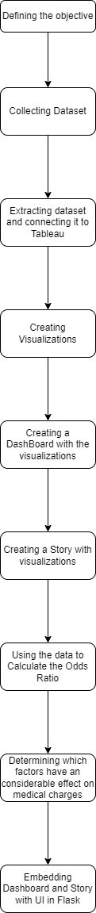

# 6. Result

The project's effectiveness in providing clear and actionable insights into hospitalization and medical care costs was supported by the comprehensive analysis of the visualizations. The visual representations successfully showcased various patterns, trends, and relationships within the data, enabling stakeholders to gain a deeper understanding of cost patterns and make informed decisions. The results of the analysis highlighted the positive correlation between BMI and charges, indicating that individuals with higher BMI tend to have higher medical costs along with high number of other results. Additionally, the distribution of charges across different regions showcased regional variations in healthcare expenses. Another example is the heatmaps visualizing charges by age and smoking status further revealed that smokers generally incur higher medical costs across all age groups. The insights derived from all the visualizations offer valuable opportunities for healthcare organizations, policymakers, and individuals to optimize cost management and resource allocation. By leveraging the power of data visualization techniques, stakeholders can identify cost-saving measures, allocate resources effectively, and make informed decisions regarding healthcare management. The project's findings underscore the importance of utilizing visualizations to gain insights into complex healthcare cost data, providing a valuable tool for driving evidence-based decision-making in the healthcare sector. The different components of this project will be covered as follows:

**6.1. Dataset:**

The dataset "[Insurance Cost Prediction"](https://www.kaggle.com/datasets/mirichoi0218/insurance) available on Kaggle is a comprehensive collection of insurance data that provides insights into factors influencing insurance costs. This dataset includes information such as age, sex, BMI, number of children, smoking status, region, and medical charges. With more than 1300 records, this dataset offers a diverse range of data for analysis and exploration. Each record contains essential attributes that contribute to understanding the factors that affect insurance costs. By utilizing this dataset, various factors that influence insurance costs were analysed through visualizations. The dataset's comprehensive nature, including attributes such as age, sex, BMI, number of children, smoking status, region, and medical charges, allows for in-depth analysis and insights. Through data exploration and numerous correlations and patterns within the dataset were uncovered.

For example, how one’s medical expenses increase with increasing BMI.

**6.2. Visualizations:**

**6.2.1. Age vs Sex vs Charges:**

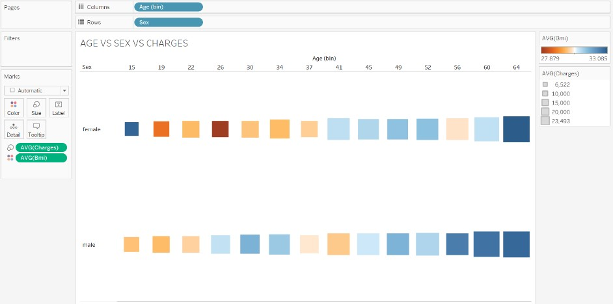

This chart shows the difference in charges depending upon the sex and the BMI of the population. Greater the square size, the greater the average charge for that group. Warmer colours represent lower average BMI, and the colder colours represent the larger BMI. In both cases we can see that people with greater BMI have to deal with greater charges.

**6.2.2. Avg. Charges vs Sex vs Smoker:**

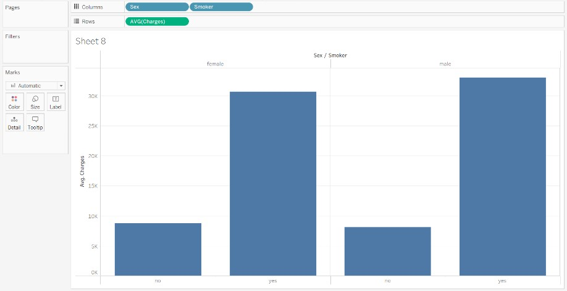

This is a bar chart where the two bar are separated by the person’s sex and the segments depend upon whether they are smokers or not. Here it can be easily seen that the part of population with greatest charges are males who smoke.

**6.2.3. BMI Weight Classification Pie Chart:**

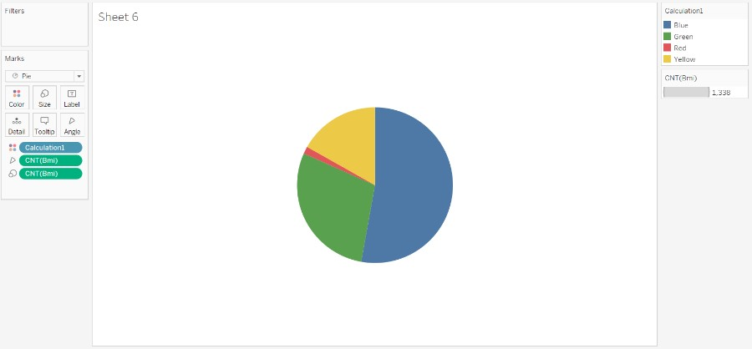

This chart is a pie chart. It classifies the population into sections of the pie according to their BMI. The pie is divided into four sections, underweight, normal weight, slightly obese and obese. Most of the population fall in the obese category which is a health concern.

**6.2.4. BMI vs Charges vs Smoker:**

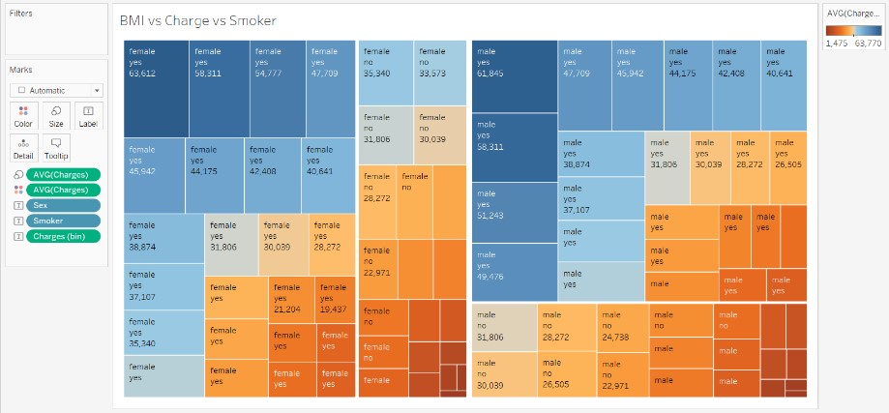

This chart is a tree map that separates the population in accordance with their sex and their respective average charge. From this tree map, it can be inferred that the average charge is greater for people of both sexes when they are smokers.

**6.2.5. BMI vs Charges:**

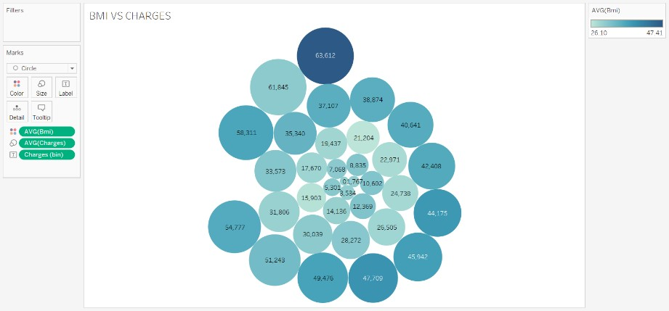

This chart shows the difference in average charges with respect to the average BMI. Here the bigger the circle, the bigger the charge and the bluer the hue, the greater the average BMI. From this, it can be inferred that greatest average charge is associated with people with greatest BMI.

**6.2.6. Cost vs Age for Obese and Non-Obese Population:**

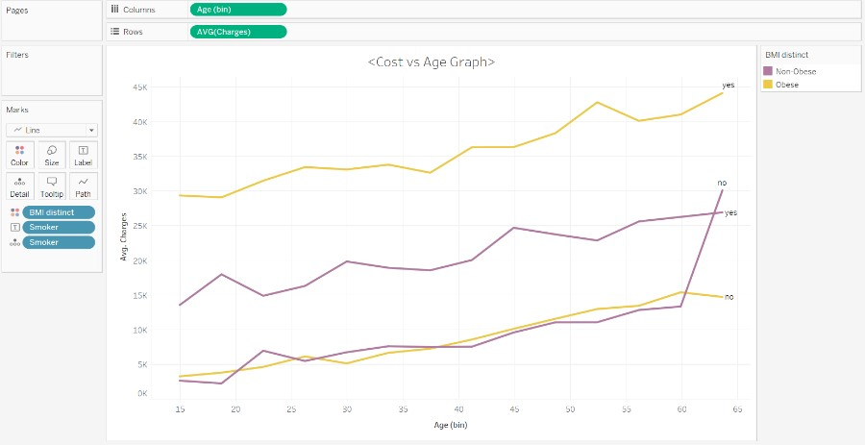

This line graph is used to show the trend of average charges over the ages. the lines are also defined by whether the people are smokers or not and whether they are obese or not. As it is inferred here, the people who are both obese and smoke, have the greatest number of average charges.

**6.2.7. Obesity vs Smoking Charges for each Sex:**

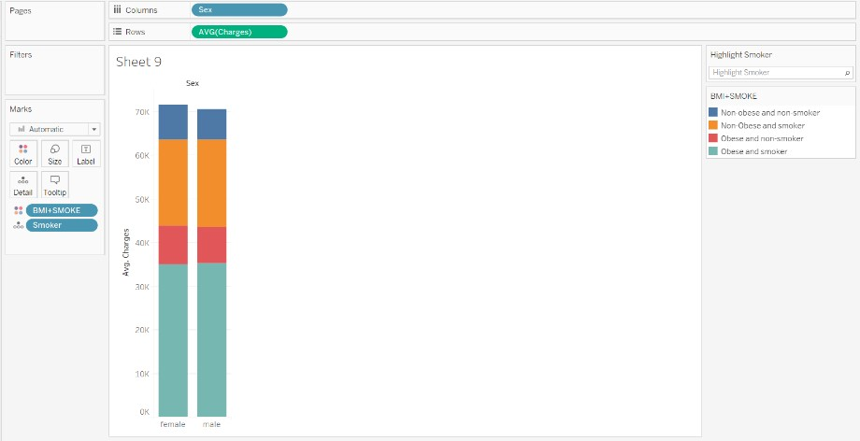

This is a stacked bar chart where the two bar are separated by the person’s sex and the segments depend upon whether they are smokers or not and whether they are obese or not. This leads to 4 combinations for each gender namely, smoker and obese, obese and non-smoker, smoker and non-obese and nonsmoker and non-obese. Here it can be easily seen that the part of population with greatest charges are males who are obese and who smoke.

**6.2.8. Smoker to Non-Smoker Ratio:**

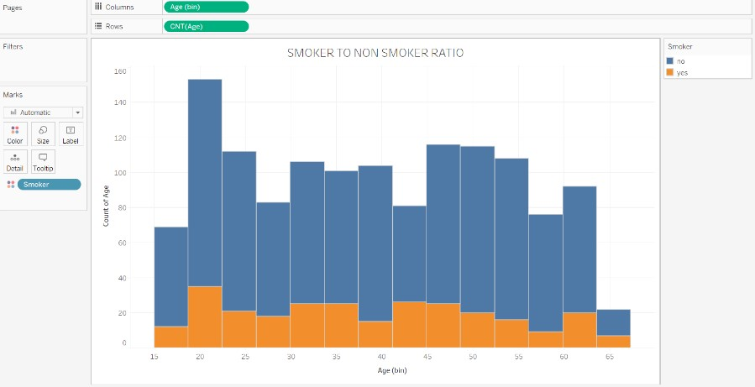

A bar chart showing the count of people according to age and where they smoke or not. It can be inferred that most of the people don’t smoke, and the age of the people is between 15 to 60, with most people being under 40.

**6.2.9. Odds Ratio:**

* + 1. OR for Smoker.
    2. OR for distinct BMI.
    3. OR for Sex.

The visualizations for each are as follows:

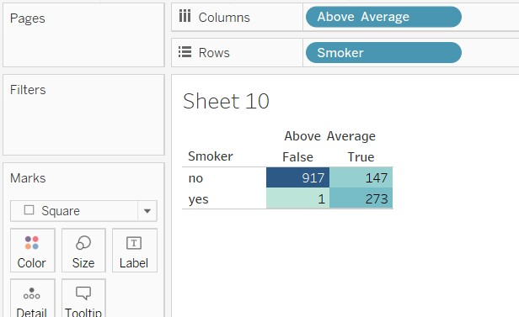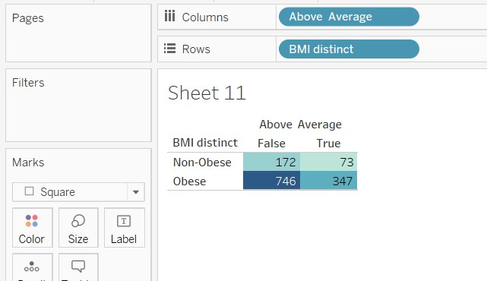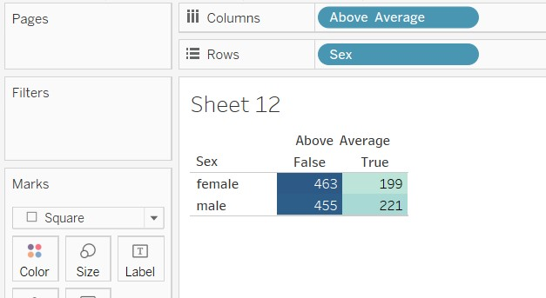

These are the tables that are used to calculate the Odd Ratio of the cause of high charges. Here the population is divided into groups who must pay above average charges and whether they are obese or smoke or are of certain sex, etc.

**6.2.10. Charges per Age Range:**

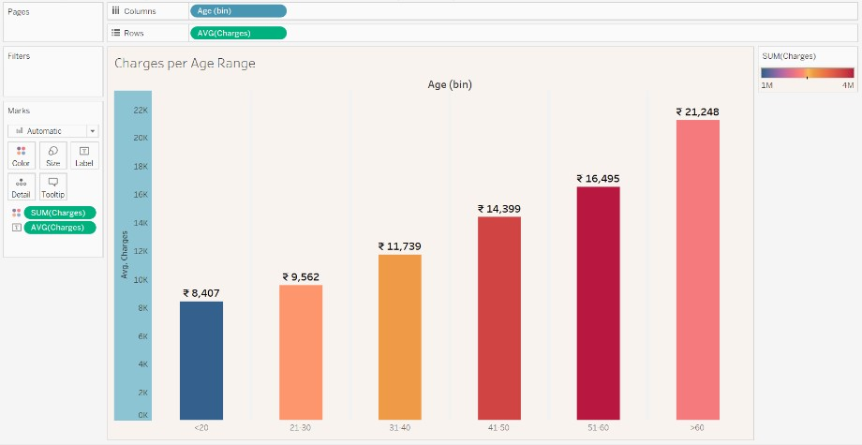

This bar chart visualization provides valuable insights into the relationship between age and medical expenses. It allows for a quick comparison of average charges in various age groups, helping identify potential trends and patterns that can inform decisions related to healthcare cost management and planning. It contains currency labelling and gradual decolouring to indicate the rise in medical charges. It can be inferred that medical expenses increases along with age.

**6.2.11. Charges per Age per Children:**

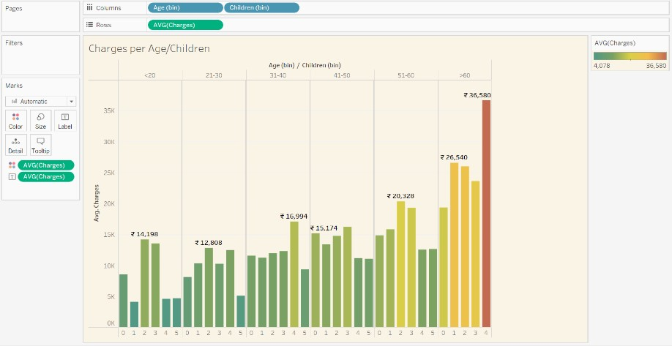

The bar chart visualization illustrating the average charges across different age ranges and the number of children provides a comprehensive view of the impact of both age and family size on medical expenses. It enables the comparison of average charges within each age range and the variation based on the number of children, offering valuable insights for healthcare cost analysis and planning. It can be observed that people over 60 with 4 children have the highest medical expenses.

**6.2.12. Region wise Charges Percentage and Avg. BMI:**

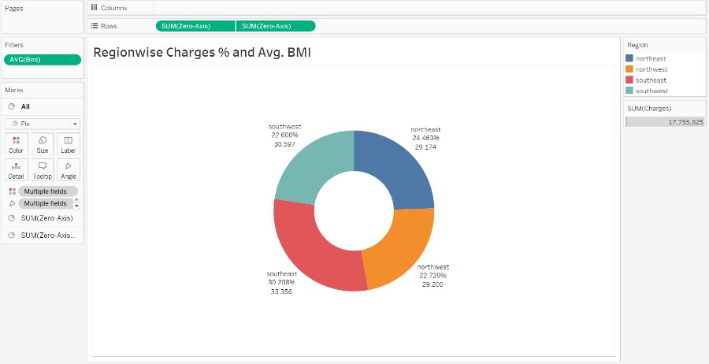

This is a doughnut chart. This type of chart is not a built-in chart in tableau. It was created by incorporating a calculated field named zero axis with value 0 and mirroring a pie chart across it. The doughnut chart visualization showcasing the region-wise charges percentage and average BMI offers a concise overview of the distribution of healthcare charges and the average BMI across different regions. It provides a visual representation of the relative proportions and average BMI values, enabling quick comparisons and insights into regional variations in healthcare costs and BMI levels. It can be concluded that the southeast region has the highest average BMI and highest medical expenses respectively.

**6.2.13. Male vs Female Charges per BMI:**

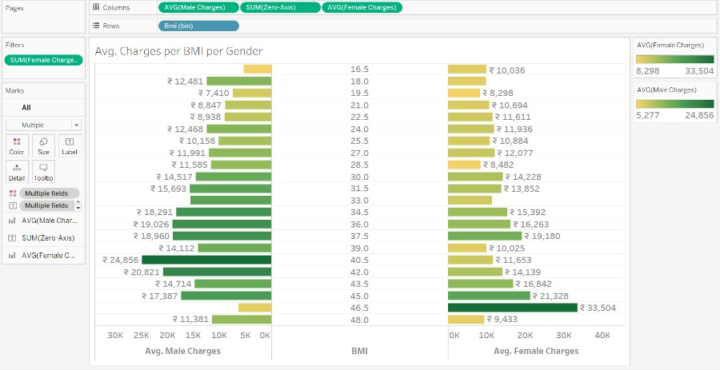

This is a butterfly chart. This type of chart is not a built-in chart in tableau. It was created by incorporating few calculated fields namely male charges, female charges and previously mentioned zero axis. This offers a unique and intuitive way to examine the cost disparities between genders at different BMI levels. By visually representing the charges on either side of the chart and aligning them with specific BMI points, it enables direct comparisons and insights into potential gender-based differences in healthcare expenses. It assists in identifying potential gender-specific healthcare cost patterns and inform policy decisions related to cost optimization and equitable healthcare access. It can be concluded that obese males tend to have higher medical expenses than obese females.

**6.2.14. Smoker vs Non-Smoker Charges per Age Range:**

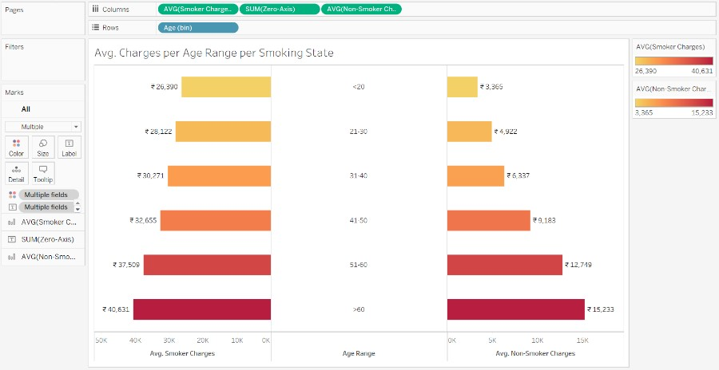

This is a butterfly chart. This type of chart is not a built-in chart in tableau. It was created by incorporating few calculated fields namely smoker charges, non-smoker charges and previously mentioned zero axis. This offers a unique and intuitive way to examine the cost disparities between smokers and non-smokers at different age ranges. By visually representing the charges on either side of the chart and aligning them with specific age ranges, it enables direct comparisons and insights into potential smoking status-based differences in healthcare expenses. It assists in identifying potential smoking-specific healthcare cost patterns and inform policy decisions related to cost optimization and equitable healthcare access. It can be concluded that smokers tend to have higher medical expenses than non-smokers.

**6.3. Dashboard:**

The four dashboards which were created from the collection of 15 visualizations offer comprehensive insights into various aspects of hospitalization and medical care costs. Each dashboard presents a focused set of visualizations, allowing users to explore different factors such as age, BMI, region, and gender, providing a holistic understanding of the cost dynamics and aiding in data-driven decisionmaking. The four dashboards are as follows:

* + - Dashboard 1 presents a comprehensive overview of hospitalization and medical care costs. The bar chart comparing sex vs smoker status highlights the distribution of smokers and nonsmokers. The bar chart showing average charges per age range per number of children offers insights into cost variations. The stacked bar chart compares charges between male and female for different combinations of smoker and obesity. The bar graph depicts the distribution of smokers and non-smokers. Lastly, the average charges per age range visualization provides a comprehensive understanding of cost trends across different age groups. Dashboard 1 is as follows:
    - Dashboard 2 offers valuable insights into the relationship between gender, BMI, region, and medical charges. The butterfly chart compares charges between males and females at each BMI point. The doughnut chart showcases the distribution of charges and average BMI across different regions. The pie chart classifies the population into various weight classes, providing a comprehensive overview of the weight distribution within the dataset.
    - Dashboard 3 provides in-depth analysis of the relationship between BMI, charges, age, gender, and smoking status. The bubble chart compares charges based on BMI, showcasing differences between males and females. The heatmap visualizes the relationship between age, BMI, and charges. The odd ratio analysis explores the impact of distinct BMI, sex, and smoking status on medical costs, enabling deeper insights into cost drivers.
    - Dashboard 4 offers unique visualizations to understand the impact of smoking on medical charges. The tree map presents the distribution of charges based on BMI, charges, and smoking status. The butterfly chart compares charges between smokers and non-smokers across different age ranges. These visualizations provide valuable insights into the relationship between smoking, BMI, and medical costs, aiding in understanding cost disparities among different groups.

Dashboard 1:

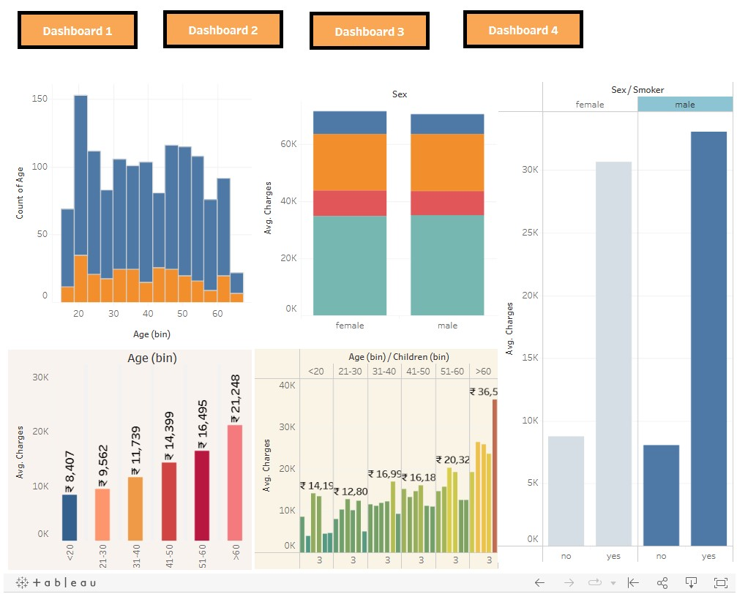

Dashboard 2:

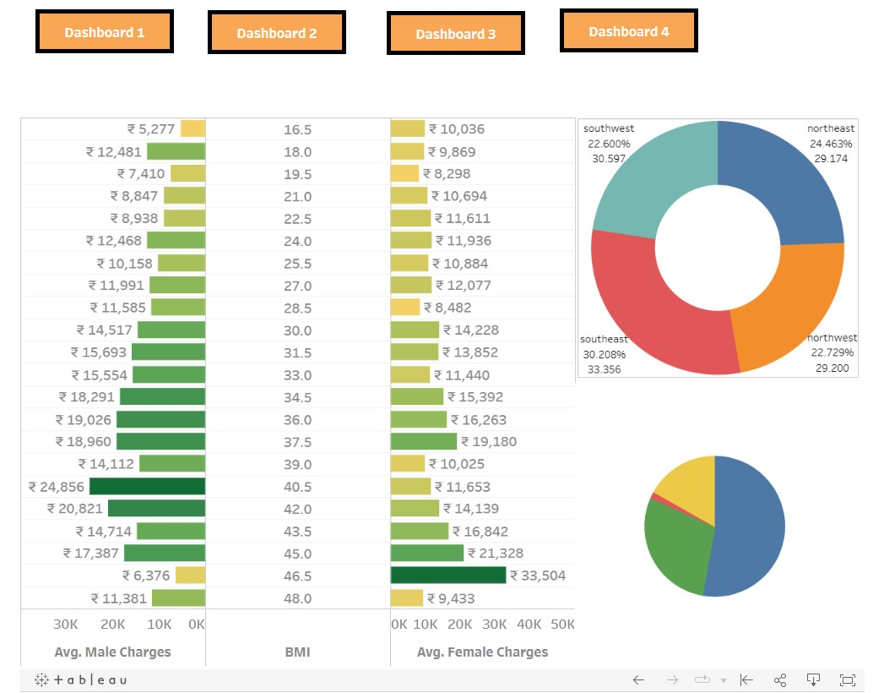

Dashboard 3:

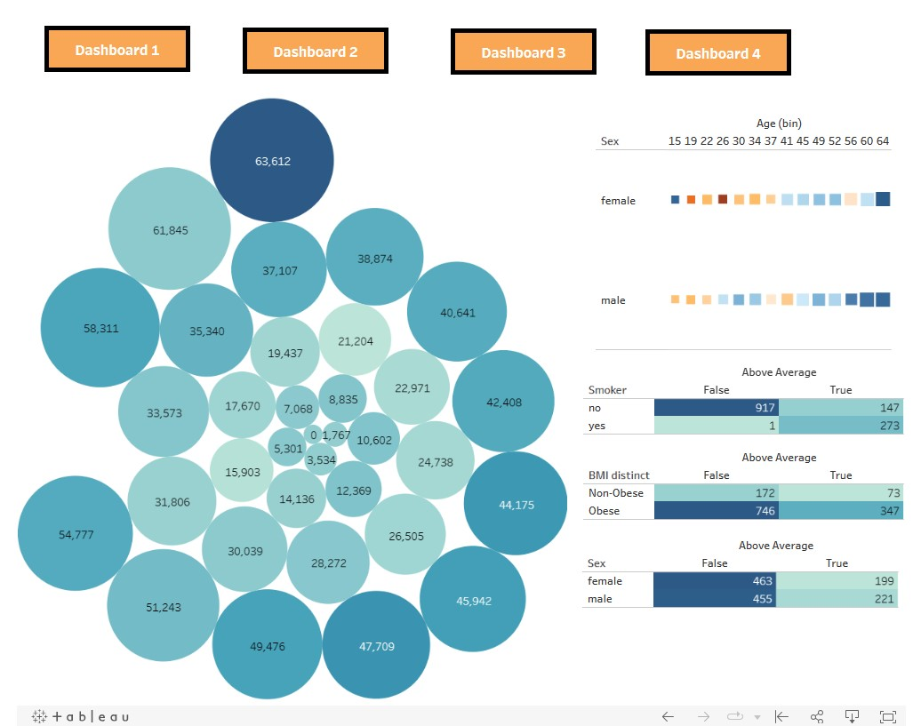

Dashboard 4:

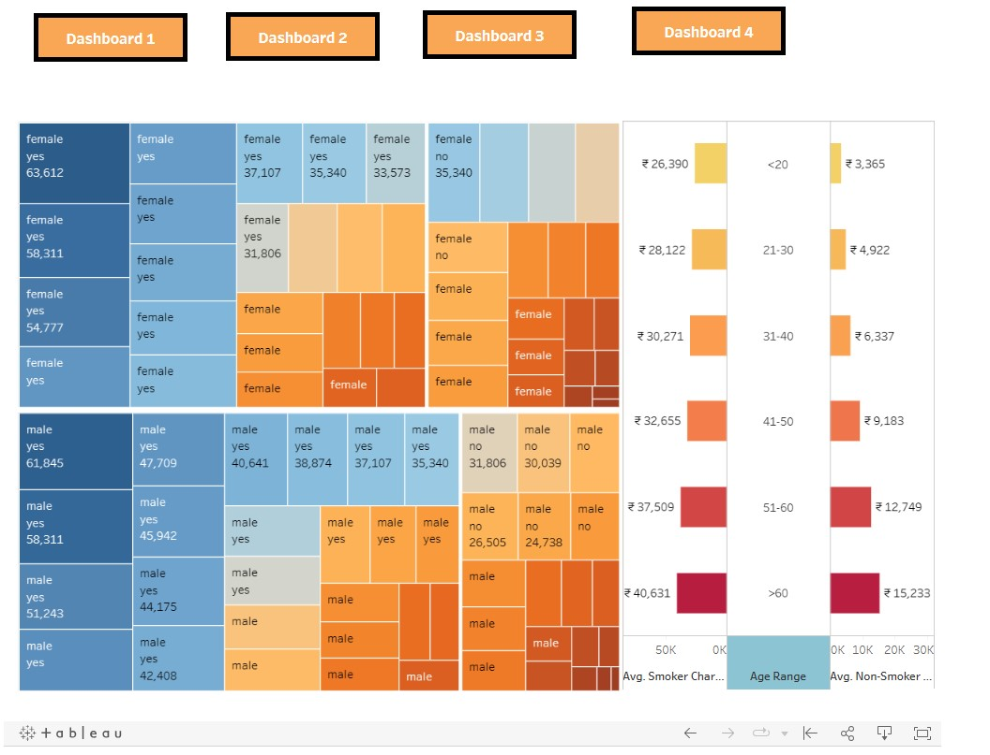

**6.4. Story:**

Our project utilized a total of 14 powerful visualizations to tell a compelling story about hospitalization and medical care costs. Each chart played a crucial role in unravelling key insights and patterns within the dataset. From bar charts and bubble charts to doughnut charts and tree maps, these visualizations provided a comprehensive view of factors such as age, gender, BMI, smoking status, region, and their impact on medical charges. By analysing these visualizations collectively, we were able to uncover meaningful trends, disparities, and relationships, empowering stakeholders to make informed decisions and optimize healthcare management. Here’s a collage of the story slides:

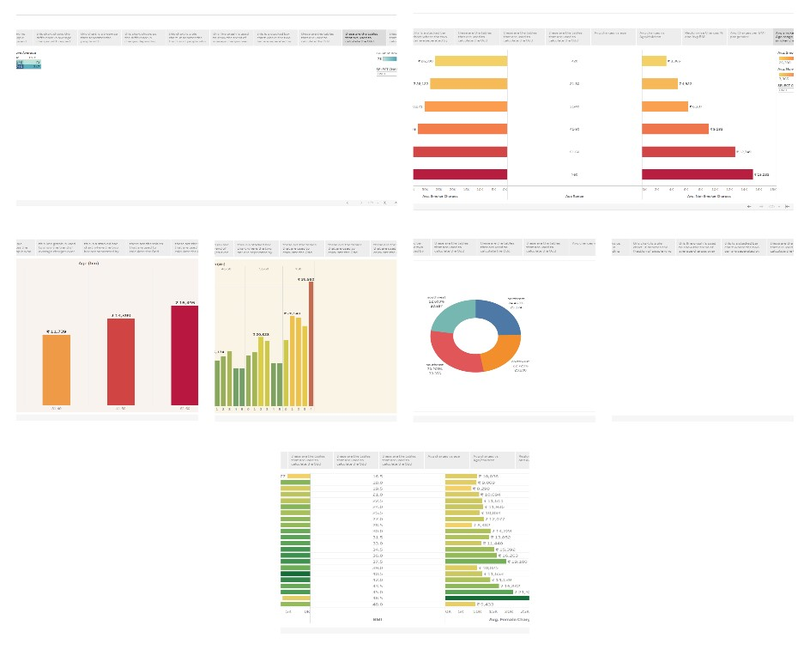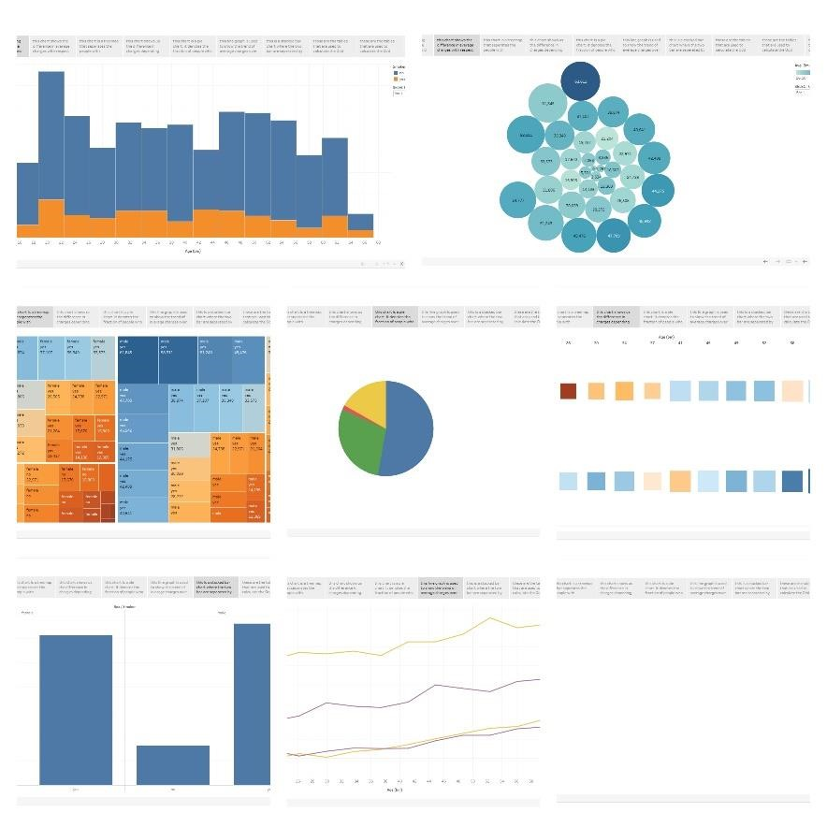

**6.5. Bootstrap:**

The free Bootstrap template "[Medicio"](https://bootstrapmade.com/medicio-free-bootstrap-theme/) served as the foundation for our website, Medistats. Through thoughtful modifications and customization, we transformed it into a unique and tailored platform specifically designed to showcase our project on the estimation and prediction of hospitalization and medical care costs. The Medicio template provided a solid framework that we enhanced with our project's branding, content, and interactive features, resulting in the creation of Medistats, a visually appealing and user-friendly website.

**6.6. Flask Deployment:**

To launch our website, we utilized Flask, a powerful web framework for Python. With Flask, we were able to seamlessly deploy our website and make it accessible to users. Flask provided us with the necessary tools to handle routing and to create dynamic pages. By deploying our website with Flask, we ensured its stability, scalability, and efficient performance, allowing users to access and navigate our platform seamlessly.

# 7. Advantages and Disadvantages

**7.1. Advantages:**

Our project provides several advantages that contribute to its value and impact. These advantages are as follows:

1. Improved Cost Management: Our project provides valuable insights into hospitalization and medical care costs, enabling healthcare organizations to better understand cost patterns and optimize resource allocation. This leads to improved cost management and enhances financial sustainability.
2. Informed Decision-Making: By visualizing complex healthcare data, our project empowers decision-makers to make informed choices regarding healthcare policies, service planning, and resource allocation. The visualizations offer a clear and intuitive representation of data, facilitating effective decision-making processes.
3. Enhanced Understanding of Cost Drivers: Through the analysis of various factors such as age, BMI, smoking status, and region, our project helps identify key drivers of medical costs. This understanding allows for targeted interventions and strategies to manage and control healthcare expenses.
4. Improved Healthcare Planning: The project's insights aid in better healthcare planning by identifying high-cost areas, assessing regional variations, and understanding population health trends. This information assists in designing efficient healthcare systems, allocating resources effectively, and improving overall healthcare delivery.
5. Empowering Patients: Our project empowers individuals to understand and anticipate their medical costs, enabling them to make informed choices regarding insurance coverage, healthcare utilization, and financial planning. This enhances patient engagement and promotes transparency in healthcare pricing.
6. Time Efficiency: Our project saves valuable time by providing quick access to visualized data insights. Instead of spending hours analysing complex datasets, stakeholders can easily interpret and extract meaningful information from the visualizations, allowing for more efficient decision-making processes.
7. Increased Transparency: The project promotes transparency in healthcare costs by visualizing and presenting data in a clear and accessible manner. This transparency enables patients, insurers, and policymakers to understand the factors contributing to medical expenses, fostering trust and accountability in the healthcare system.
8. Data-Driven Approach: Our project utilizes a data-driven approach to inform decision-making and policy formulation. By leveraging robust data visualizations, stakeholders can base their actions on objective evidence and insights, leading to more effective and impactful interventions.
9. Scalability and Adaptability: The project's use of Tableau and other tools allows for scalability and adaptability to changing data and analytical needs. It can handle large datasets and accommodate future expansions or modifications, ensuring its relevance and usability over time.
10. Accessibility and User-Friendliness: The project prioritizes accessibility and user-friendliness, making it easy for stakeholders with varying levels of technical expertise to navigate and interpret the visualizations. Its intuitive design and interactive features ensure that users can explore and understand the data without significant barriers or complexities.

**7.2. Disadvantages:**

While our project offers numerous advantages and valuable insights, it's important to acknowledge that every project has its limitations. Few of our project’s disadvantages include:

1. Data Limitations: One of the potential drawbacks of our project is the reliance on a specific dataset. The accuracy and reliability of the insights generated are heavily dependent on the quality and representativeness of the data used. Incomplete or biased data can lead to misleading conclusions and inaccurate predictions.
2. Limited Interactivity: Although our project offers interactive features, the level of interactivity may be limited compared to more advanced data visualization tools. Users may encounter restrictions in customizing and exploring the data beyond the predefined visualizations, potentially hindering their ability to delve deeper into specific aspects of the dataset.
3. Interpretation Challenges: Visualizations inherently require interpretation, and different users may interpret the same visualization differently. The understanding of the insights generated can vary based on the background, expertise, and biases of the individuals analyzing the data. This subjectivity can introduce potential challenges in ensuring consistent and accurate interpretations.
4. Technical Dependencies: Our project relies on specific software and technologies such as Tableau, MySQL, Flask, and Bootstrap. This dependence on various tools and frameworks may require users to have a certain level of technical expertise or access to specific resources, which could be a limitation for some users or organizations with limited technical capabilities or infrastructure.

**8. Applications:**

The application of our solution extends to various areas where the estimation and prediction of hospitalization and medical care costs can provide valuable insights and drive informed decision-making. Some potential areas of application include:

1. Healthcare Organizations: Our solution can assist healthcare organizations in analyzing cost patterns, optimizing resource allocation, and identifying areas for cost reduction. It can support strategic planning, budgeting, and financial management to ensure efficient and effective healthcare delivery.
2. Insurance Providers: Insurance companies can leverage our solution to better understand risk profiles, estimate premiums, and assess the financial impact of different factors on insurance costs. This can help in developing more accurate pricing models and offering tailored insurance plans to their customers.
3. Policy Makers: Government agencies and policymakers can utilize our solution to gain insights into healthcare cost trends, regional variations, and the impact of specific factors on medical expenses. This information can inform policy decisions related to healthcare financing, resource allocation, and regulatory frameworks.
4. Research and Academia: Our solution can be used by researchers and academics to analyze healthcare cost data, identify correlations between variables, and conduct studies on the economic aspects of healthcare. It can contribute to the body of knowledge in health economics, public health, and healthcare management.
5. Individuals and Patients: Our solution can empower individuals and patients to better understand and estimate their medical costs. It can assist in financial planning, decisionmaking regarding healthcare services, and exploring options for cost-saving measures such as lifestyle modifications or preventive care.

These are just a few examples of the diverse areas where our solution can be applied. The flexibility and adaptability of our approach allow for customization and integration into specific contexts, enabling stakeholders to harness the power of data-driven insights for improved healthcare management and decision-making.

# 9. Conclusion

In conclusion, our project on "Estimation and Prediction of Hospitalization and Medical Care Costs" has successfully addressed the problem statement by leveraging data visualization techniques. Through the integration of Tableau, MySQL, Flask, and Bootstrap, we have developed an interactive web application, "MediStats," that allows users to explore and analyze a comprehensive insurance dataset. By visualizing the dataset through various charts, such as bar charts, scatter plots, heatmaps, and tree maps, we have uncovered important patterns, trends, and relationships. The project's strengths lie in its ability to present complex information in a visually appealing and user-friendly manner. The use of interactive features allows users to customize their analysis and gain deeper insights into the dataset. Additionally, the integration of Flask as a web framework and Bootstrap for responsive design ensures a seamless and engaging user experience across different devices. The project has several key features, including the ability to explore cost variations based on age, sex, BMI, number of children, smoking status, and region. The visualizations provide a comprehensive view of cost patterns, allowing healthcare organizations, policymakers, and individuals to identify areas for cost optimization and make data-driven decisions. Although the project has showcased significant achievements, there are also limitations to consider. Due to the absence of a prediction model, we focused solely on data visualization and descriptive analysis. Overall, the project has demonstrated the value of data visualization in understanding and analysing hospitalization and medical care costs. By presenting the findings in a visually compelling manner, the project empowers stakeholders to gain actionable insights, optimize cost management, and contribute to improved healthcare decision-making.

# 10. Future Scope

Our project holds promising potential for future enhancements and expansions. Some key areas of future scope for this project include:

1. Machine Learning Integration: One potential avenue for future development is the integration of machine learning algorithms to predict and forecast medical costs. By training models on historical data, the project could provide valuable insights into future cost trends and help stakeholders make proactive decisions.
2. Advanced Analytics and Statistical Analysis: Expanding the project to include advanced analytics and statistical analysis techniques can provide deeper insights into cost patterns. This could involve conducting regression analysis, time series analysis, or clustering to uncover hidden patterns and correlations within the dataset.
3. Integration with Electronic Health Records (EHR): Integrating the project with Electronic Health Records (EHR) systems would allow for a more comprehensive analysis of patient data and medical histories. By combining insurance data with individual health records, the project could provide a more holistic understanding of the factors impacting medical costs.
4. Collaboration and Data Sharing: Implementing features that enable collaboration and data sharing among healthcare professionals, researchers, and policymakers could facilitate knowledge exchange and contribute to a more comprehensive understanding of healthcare costs. This could involve creating secure platforms for data sharing, discussion forums, or collaborative analytics tools.
5. Real-Time Data Updates: Enhancing the project to support real-time data updates would enable users to access the most up-to-date information on hospitalization and medical care costs. This could involve implementing automated data pipelines and integrating APIs to retrieve and update the dataset in real-time.